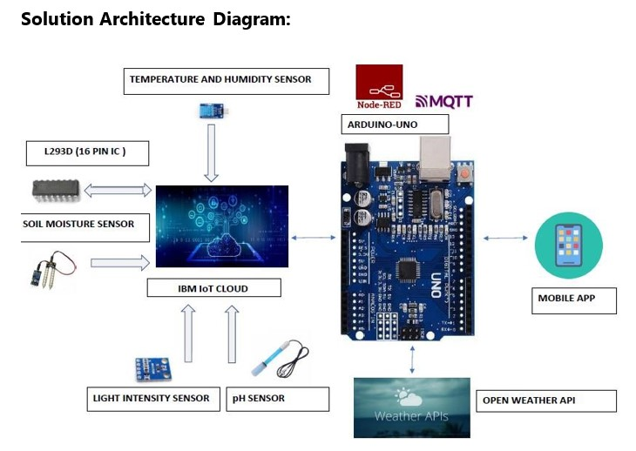

* The different soil parameters (temperature, humidity, light intensity, pH level) are sensed using different sensors and the obtained value is stored in IBM cloud.

* The L293D is a 16-pin Motor Driver IC which can control a set of two DC motors simultaneously in any direction. The L293D is designed to provide bidirectional drive currents of up to 600 mA (per channel) at voltages from 4.5 V to 36 V (at pin 8!).

* Arduino UNO is used as a processing unit which processes the data obtained from sensors and weather data from weather API.

* Node-RED is a programming tool for wiring together hardware devices, APIs and online services in new and interesting ways. It provides a browser-based editor.
* The MQTT protocol is followed for communication.

* All the collected data are provided to the user through a mobile application which was developed using MIT app inventor.

* Open Weather provides hyperlocal minute forecast, historical data, current state and from short-term to annual and forecasted weather data. All data is available via industry standard APIs.

* The user could make decision through an app, whether to water the crop or not, depending upon the sensor values.